Raspberry Pi Web Security Camera

Table of Contents

**Block Diagram** 1

**Project Summary** 2

**Project Management Plan** 3

**Gantt Chart:** 3

**Detailed description of the project, divided into following section:** 4

**A. Mechanical Design** 4

**B. Electrical design** 6

**C. Software Design** 8

**D. Network Design** 10

**D. Appendix** 17

**Raspberry pi model B+** 17

**Arduino Uno** 17

**Sg90 Servo motor** 19

**Pixycam** 20

**Troubleshoot Details:** 21

**Use of Our Device:** 21

**Future Plan:** 22

**Conclusion:** 22

# **Block Diagram**

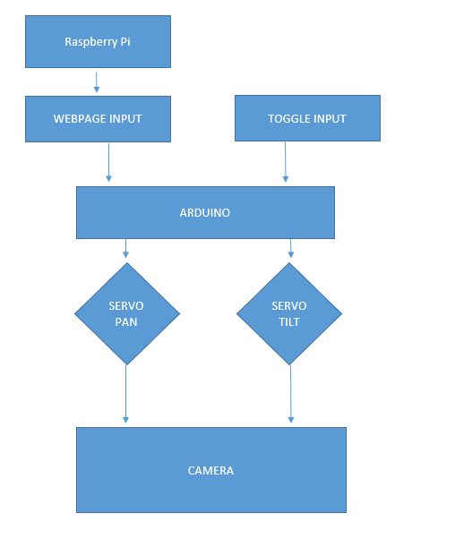

# **Project Summary**

The Purpose of our project is to monitor a security camera feed using raspberry pi that can interact with the webserver to adjust the camera module. This project will allow a user to interact on the web page to get a wider angle of web-stream using python webserver and servo motors connected to the pi webcam. The camera connected to the servo will move 4 different angles (left, right, up, down) whenever the user hit buttons on the webpage. The webpage is served by the Twisted webserver which connected to the local pi ip address. To access this service the user type pi ip address with :8081(HTTP) to get the live feed and then run the webserver then the webserver serves our html.index page which comes with buttons to interact with the camera. Finally, by clicking the buttons the camera view can be easily move in different directions so that user can get a wider view and angle. Note that, we have initialized the camera per click 10 degrees.

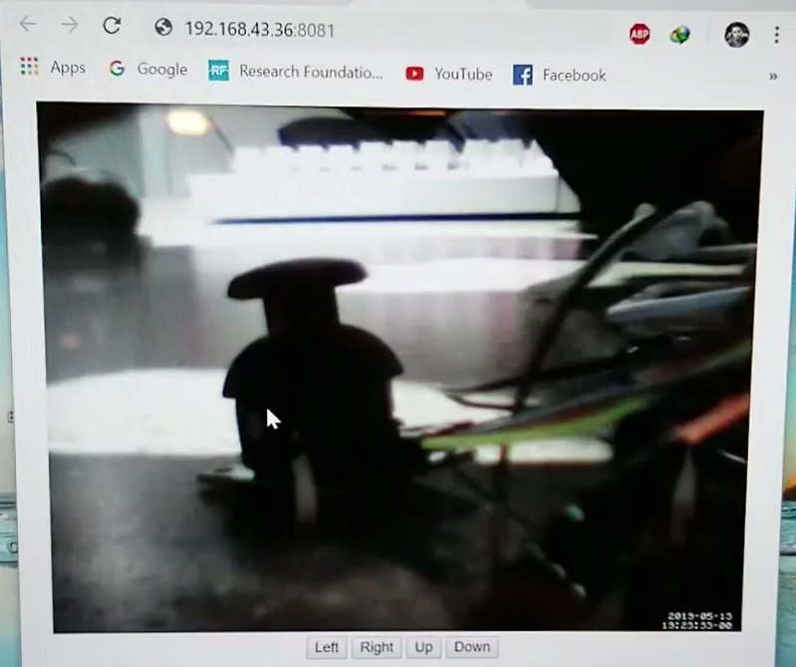

module.

# **Project Management Plan**

## **Gantt Chart:**

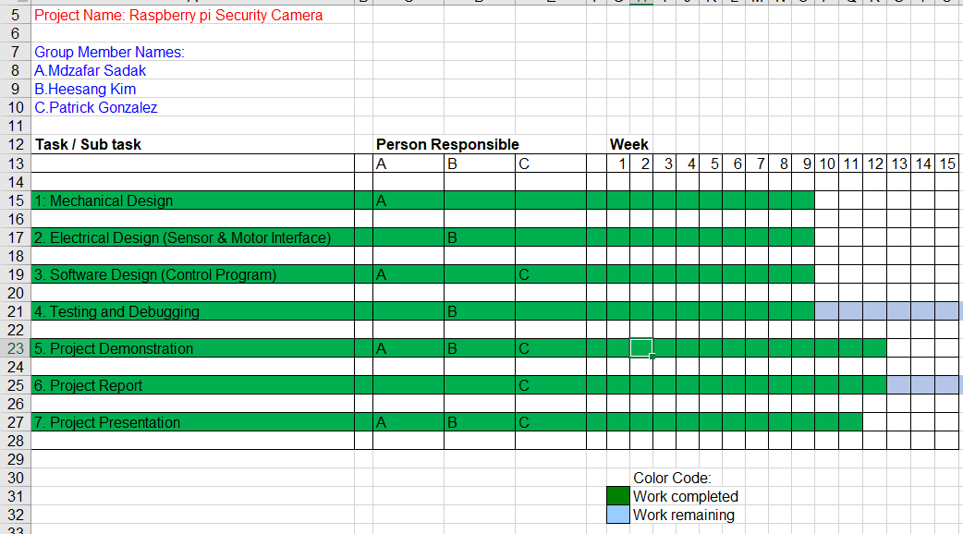

We have completed all the requirement within ninth week of this semester. Mostly mechanical design, electrical design was done by Heesang kim. He was also responsible for troubleshooting electrical components so that it keeps safe during the project design. He worked with complex mechanical model such as 3D printing to hold the camera which was one of the big achievements in this project.

Mdzafar Sadak was responsible for software, networking testing and troubleshooting codes and gather necessary data that required for this project. He was responsible to lead the team and documented each step so that we can track our progress. He also was responsible for webserver testing, building a clean html code and establish communication over the local network and webpage.

Patrick Gonzalez was responsible for creating a flowchart of overall project idea. He monitored the overall project and worked deliberately with our group.

# **Detailed description of the project, divided into following section:**

## **A. Mechanical Design**

For mechanical part of this project we used, 3d printed servo mount, 2 sg90 servo motors, screws,nuts,and bolts.

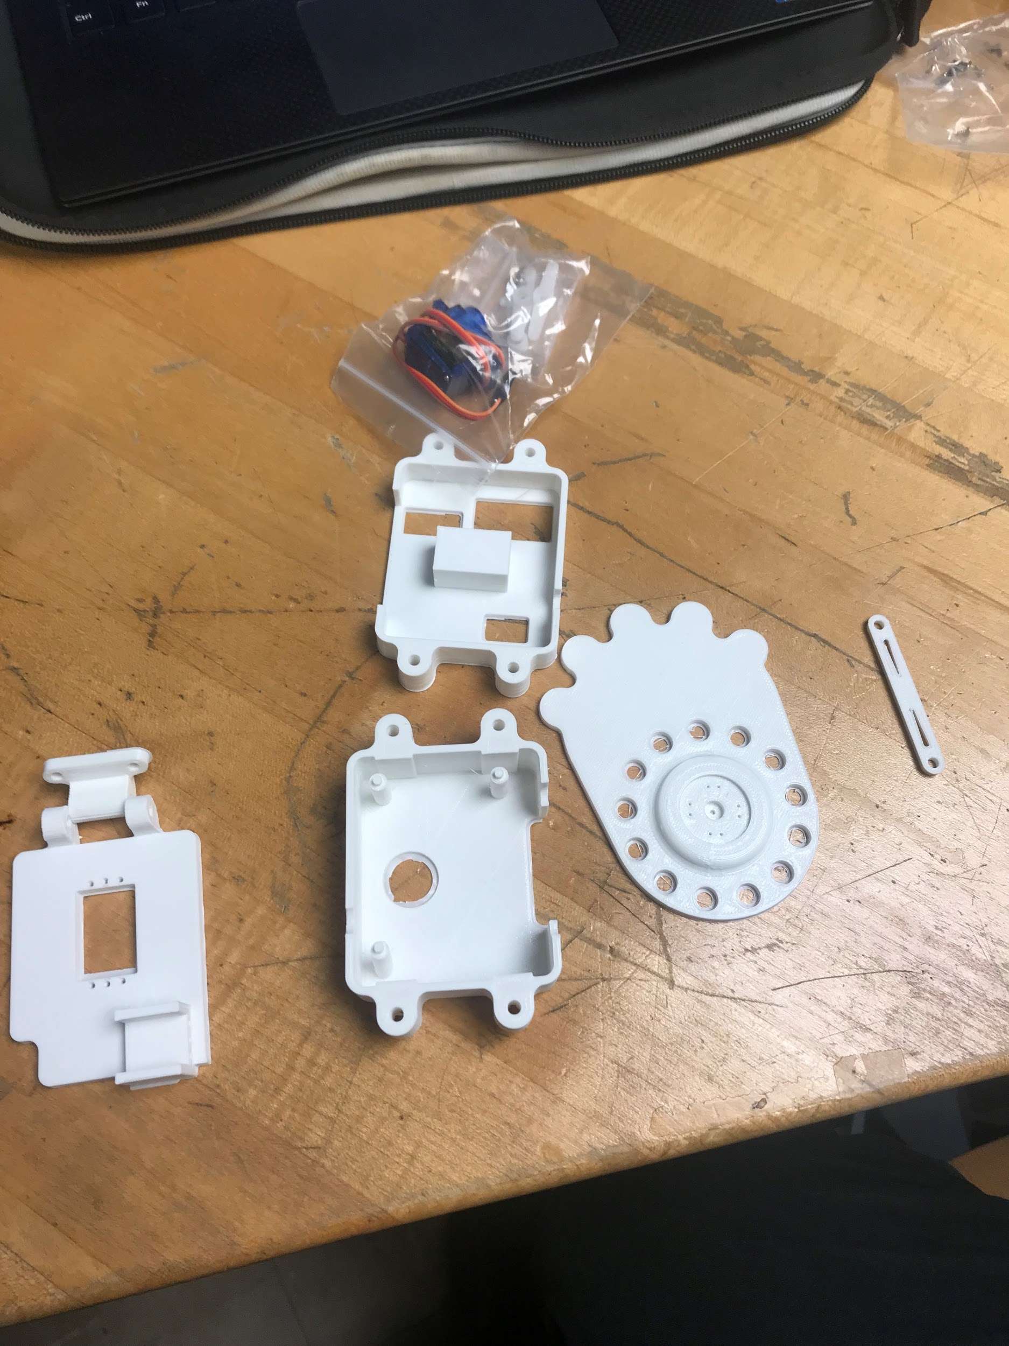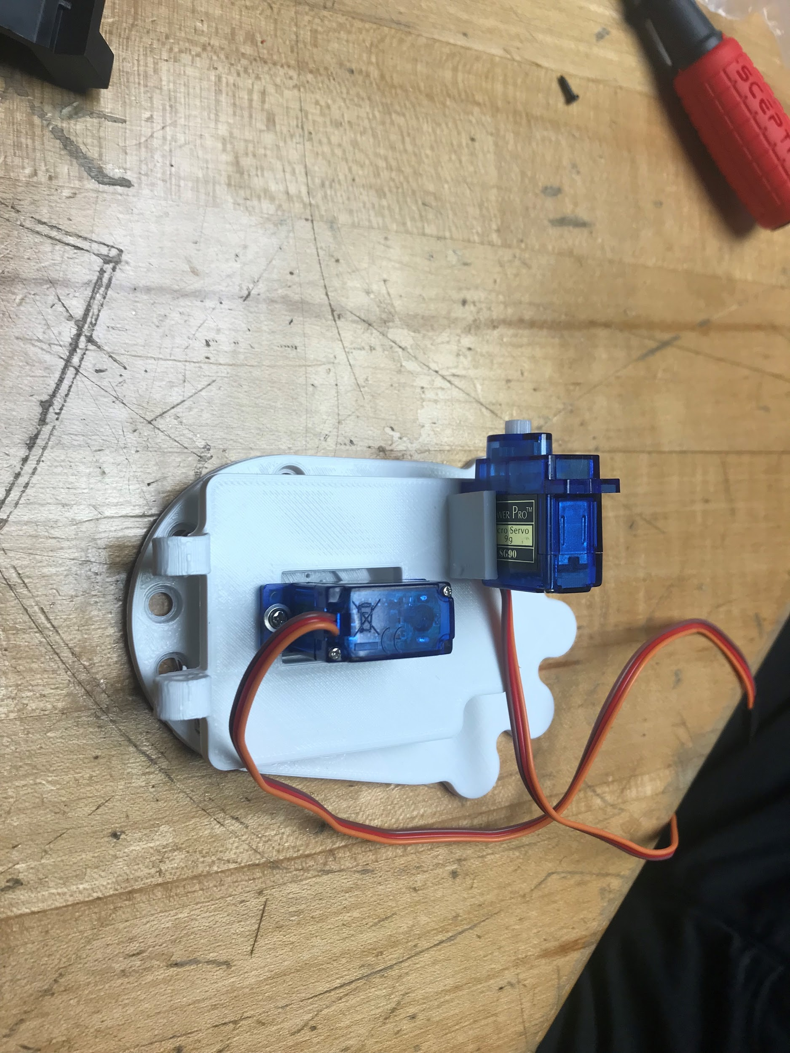

We used 3d printer to print out servo mount. CR-10 3D printer was used with PLA filament. We put about 30 percent of infills to the print. It takes 6 hours to print out the part without fail. The difficulties of 3d printing is adjust alignment of the printer before printing. Improper alignment causes faulty part or lower printing quality. To adjust it we need to inspect the pulley and belts that attached moving part of 3d printer. Make sure it is nice and tight, secure. The next hard thing was actual designing process. Since we are not a mechanical designing student it was challenged to design the holder. We get a idea from pixy camera mount and tried to make similar to that design. Then we converted to G code and inserted to 3D printer to print. The print came out with good quality. When we tried to mount servos into mount, we had difficulties that screw is not fit correctly. During the design process we didn’t make screw holes large enough so it can perfectly fit it. So, we had to manually force to put it in by hands but also very gently so the part won’t break.

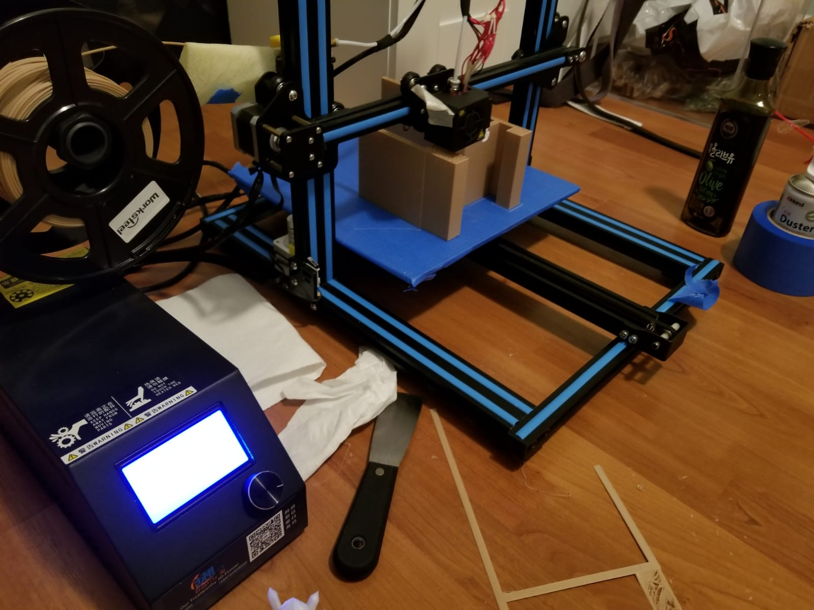

## **B. Electrical design**

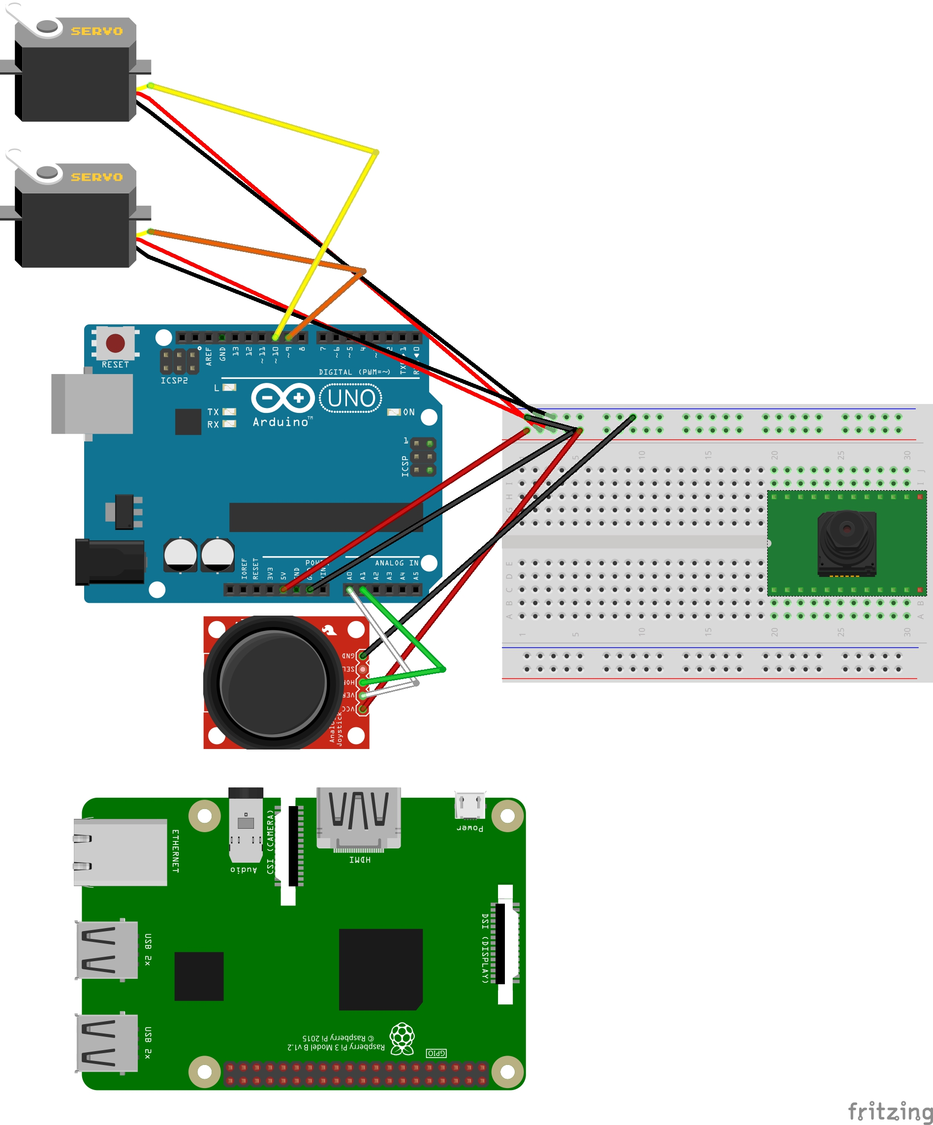

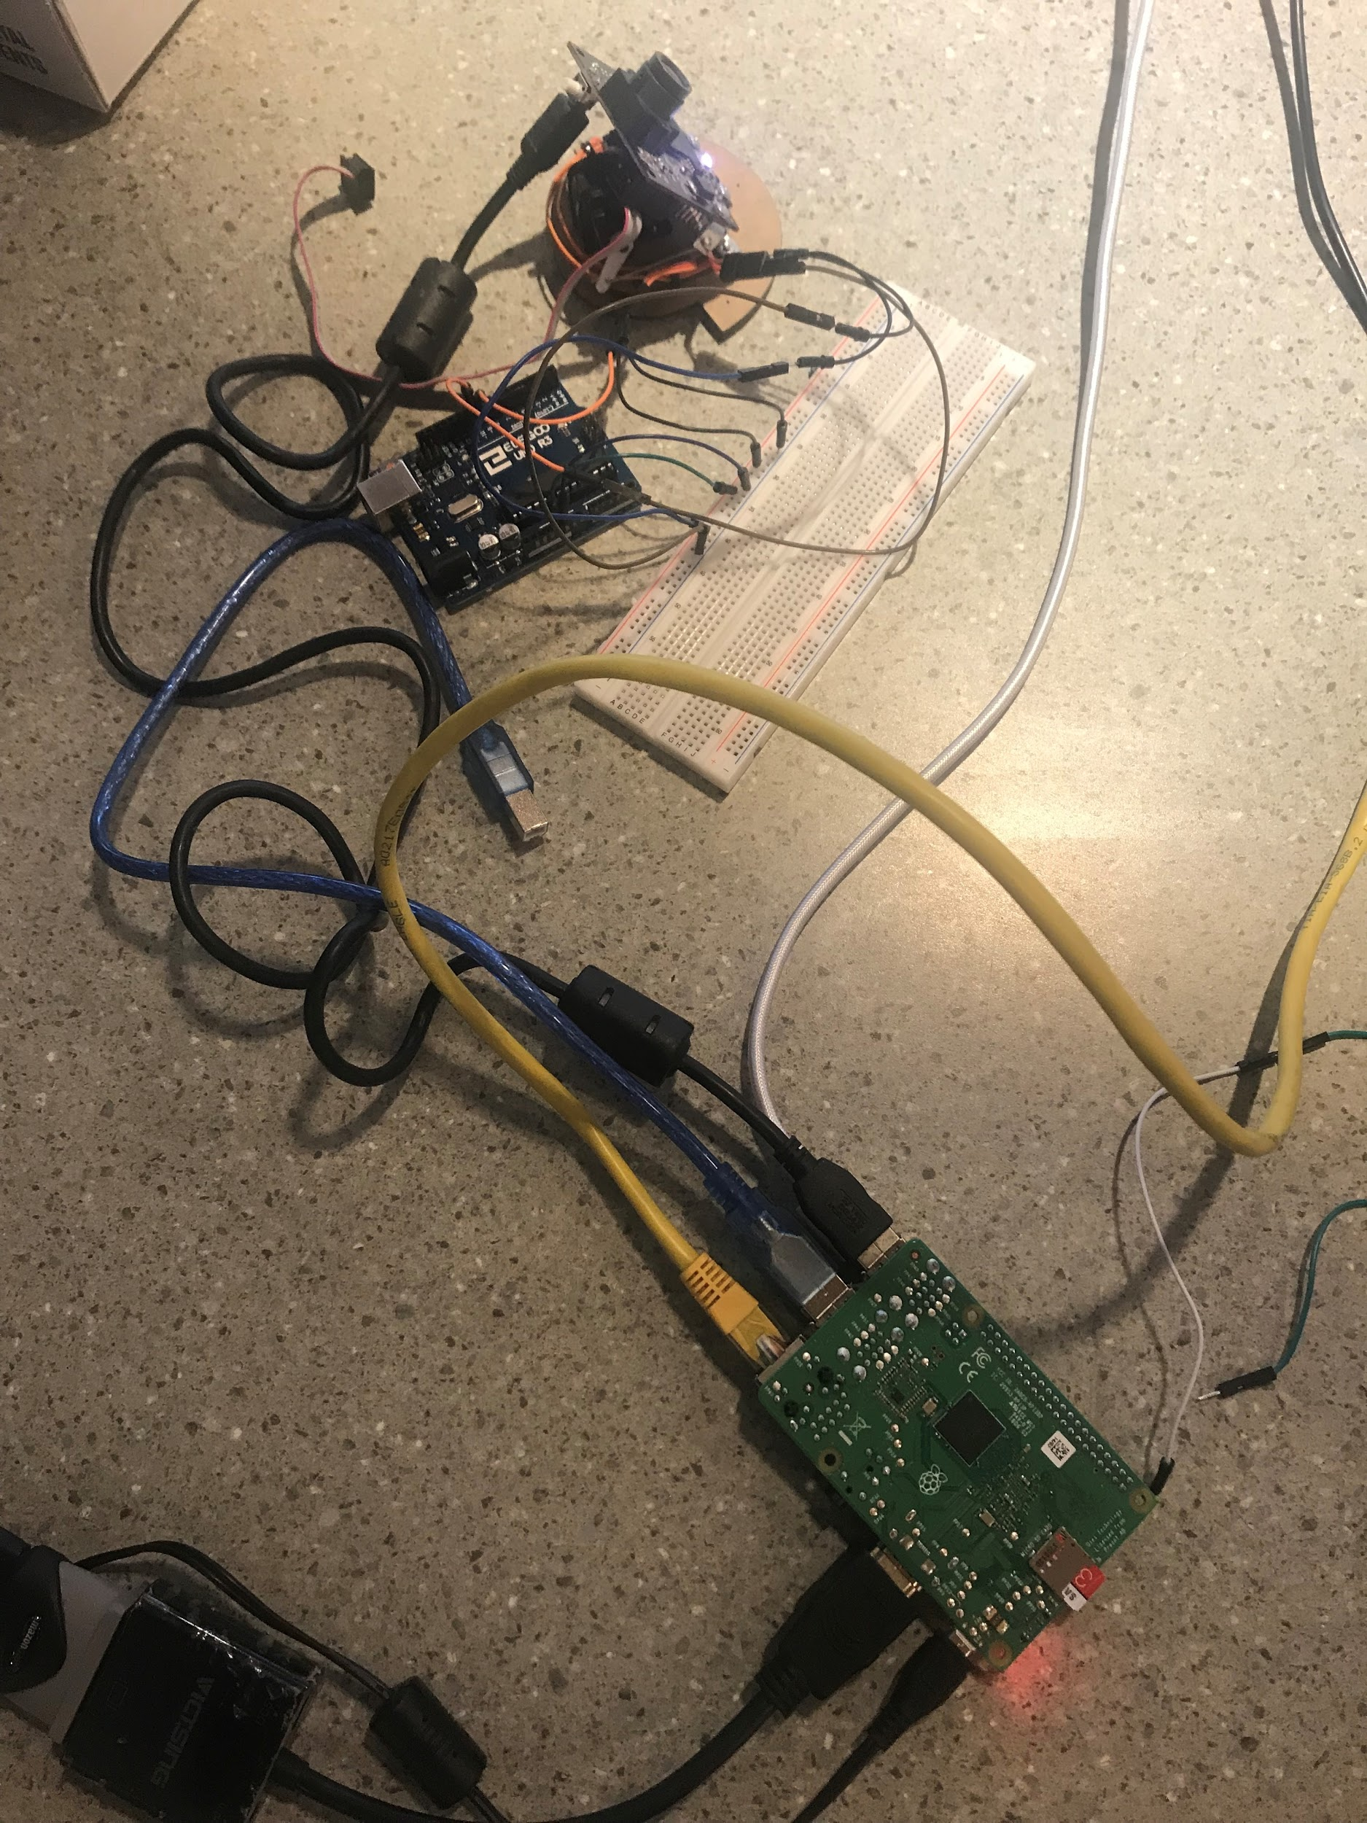

For our electrical design, we are using Raspberry pi 3 model B+, Arduino Uno, USB web camera, pixy camera. As shown in schematic, 2 servo motors will be connected to Arduino Uno pin 9 and 10. Pin 9 is control servo to move left and right, and pin 10 control servo move up and down. Then Arduino Uno is connected to Raspberry pi using serial connection. The camera will be also connected to a Raspberry pi using USB. Raspberry pi is key part of this project. It will control the Arduino, Camera, software, and website we will use. Then for optional feature, we added a joystick to arduino analogue pin A0, and A1. The joystick able to control servo motor manually. The power system of this project we are using powers from raspberry pi. Use raspberry pi 5V 2.5 amp power adaptor to power up raspberry pi, then arduino board, and camera is powered by arduino usb port.

## **C. Software Design**

1. Raspberry pi setup
2. sudo apt-get update&upgrade- upgrade pi to upto date
3. lsusb- to find the usb devices mounted to raspberry pi
4. ifconfig- to determine detailed network information such as ip address, mac address.
5. apt-get install motion – install motion package to raspberry pi
6. sudo nano/etc/motion/motion.conf- gnu nano is a text editor that linux operating system uses. For this case it direct to text file calls motion.conf. from here we can modify video settings such as size, network port.
7. Sudo nano /etc/default/motion: here we can enable motion feature on
8. apt-get install python-twisted : install python twisted package

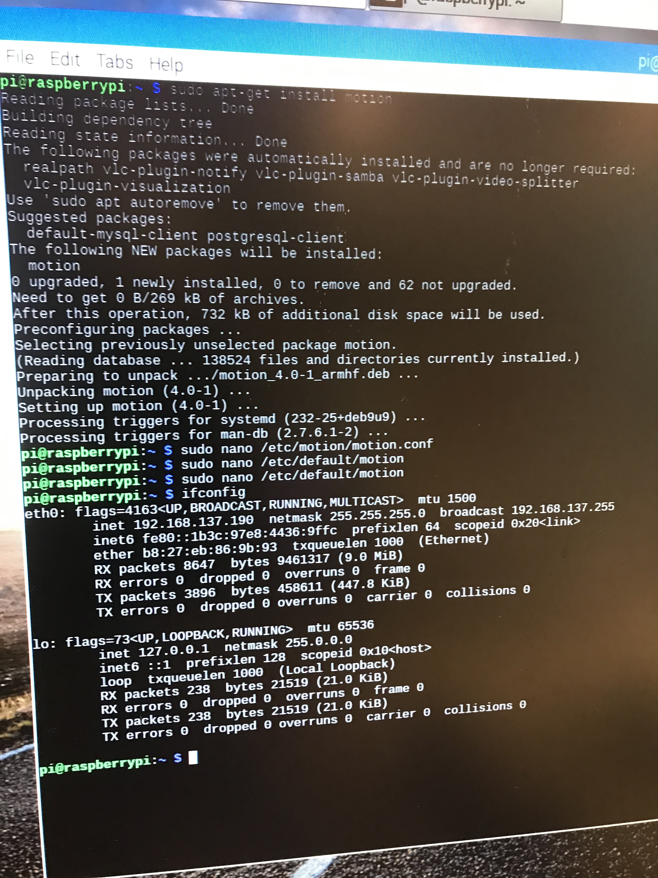

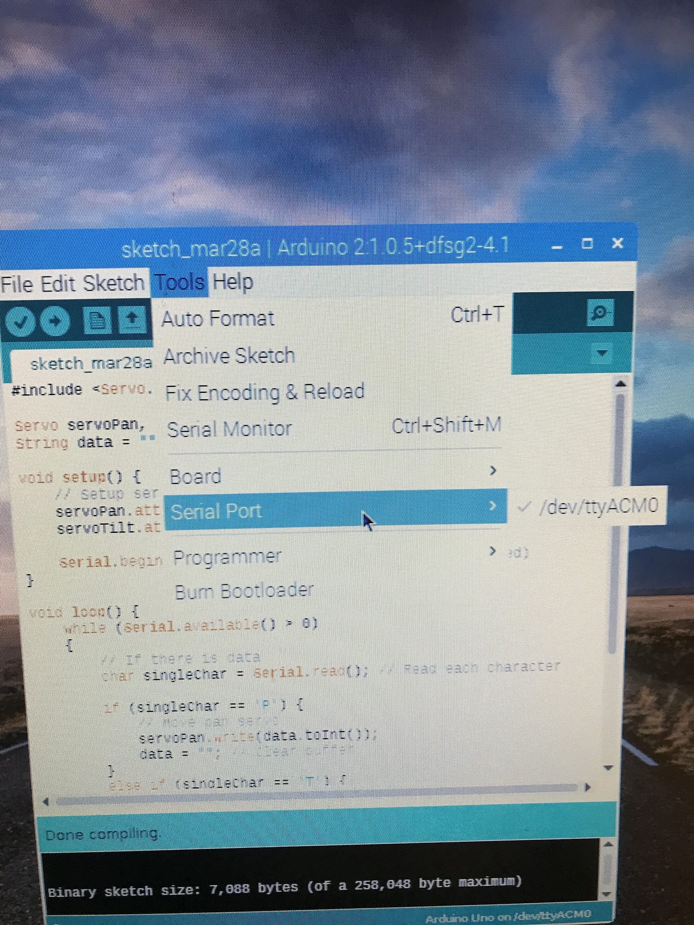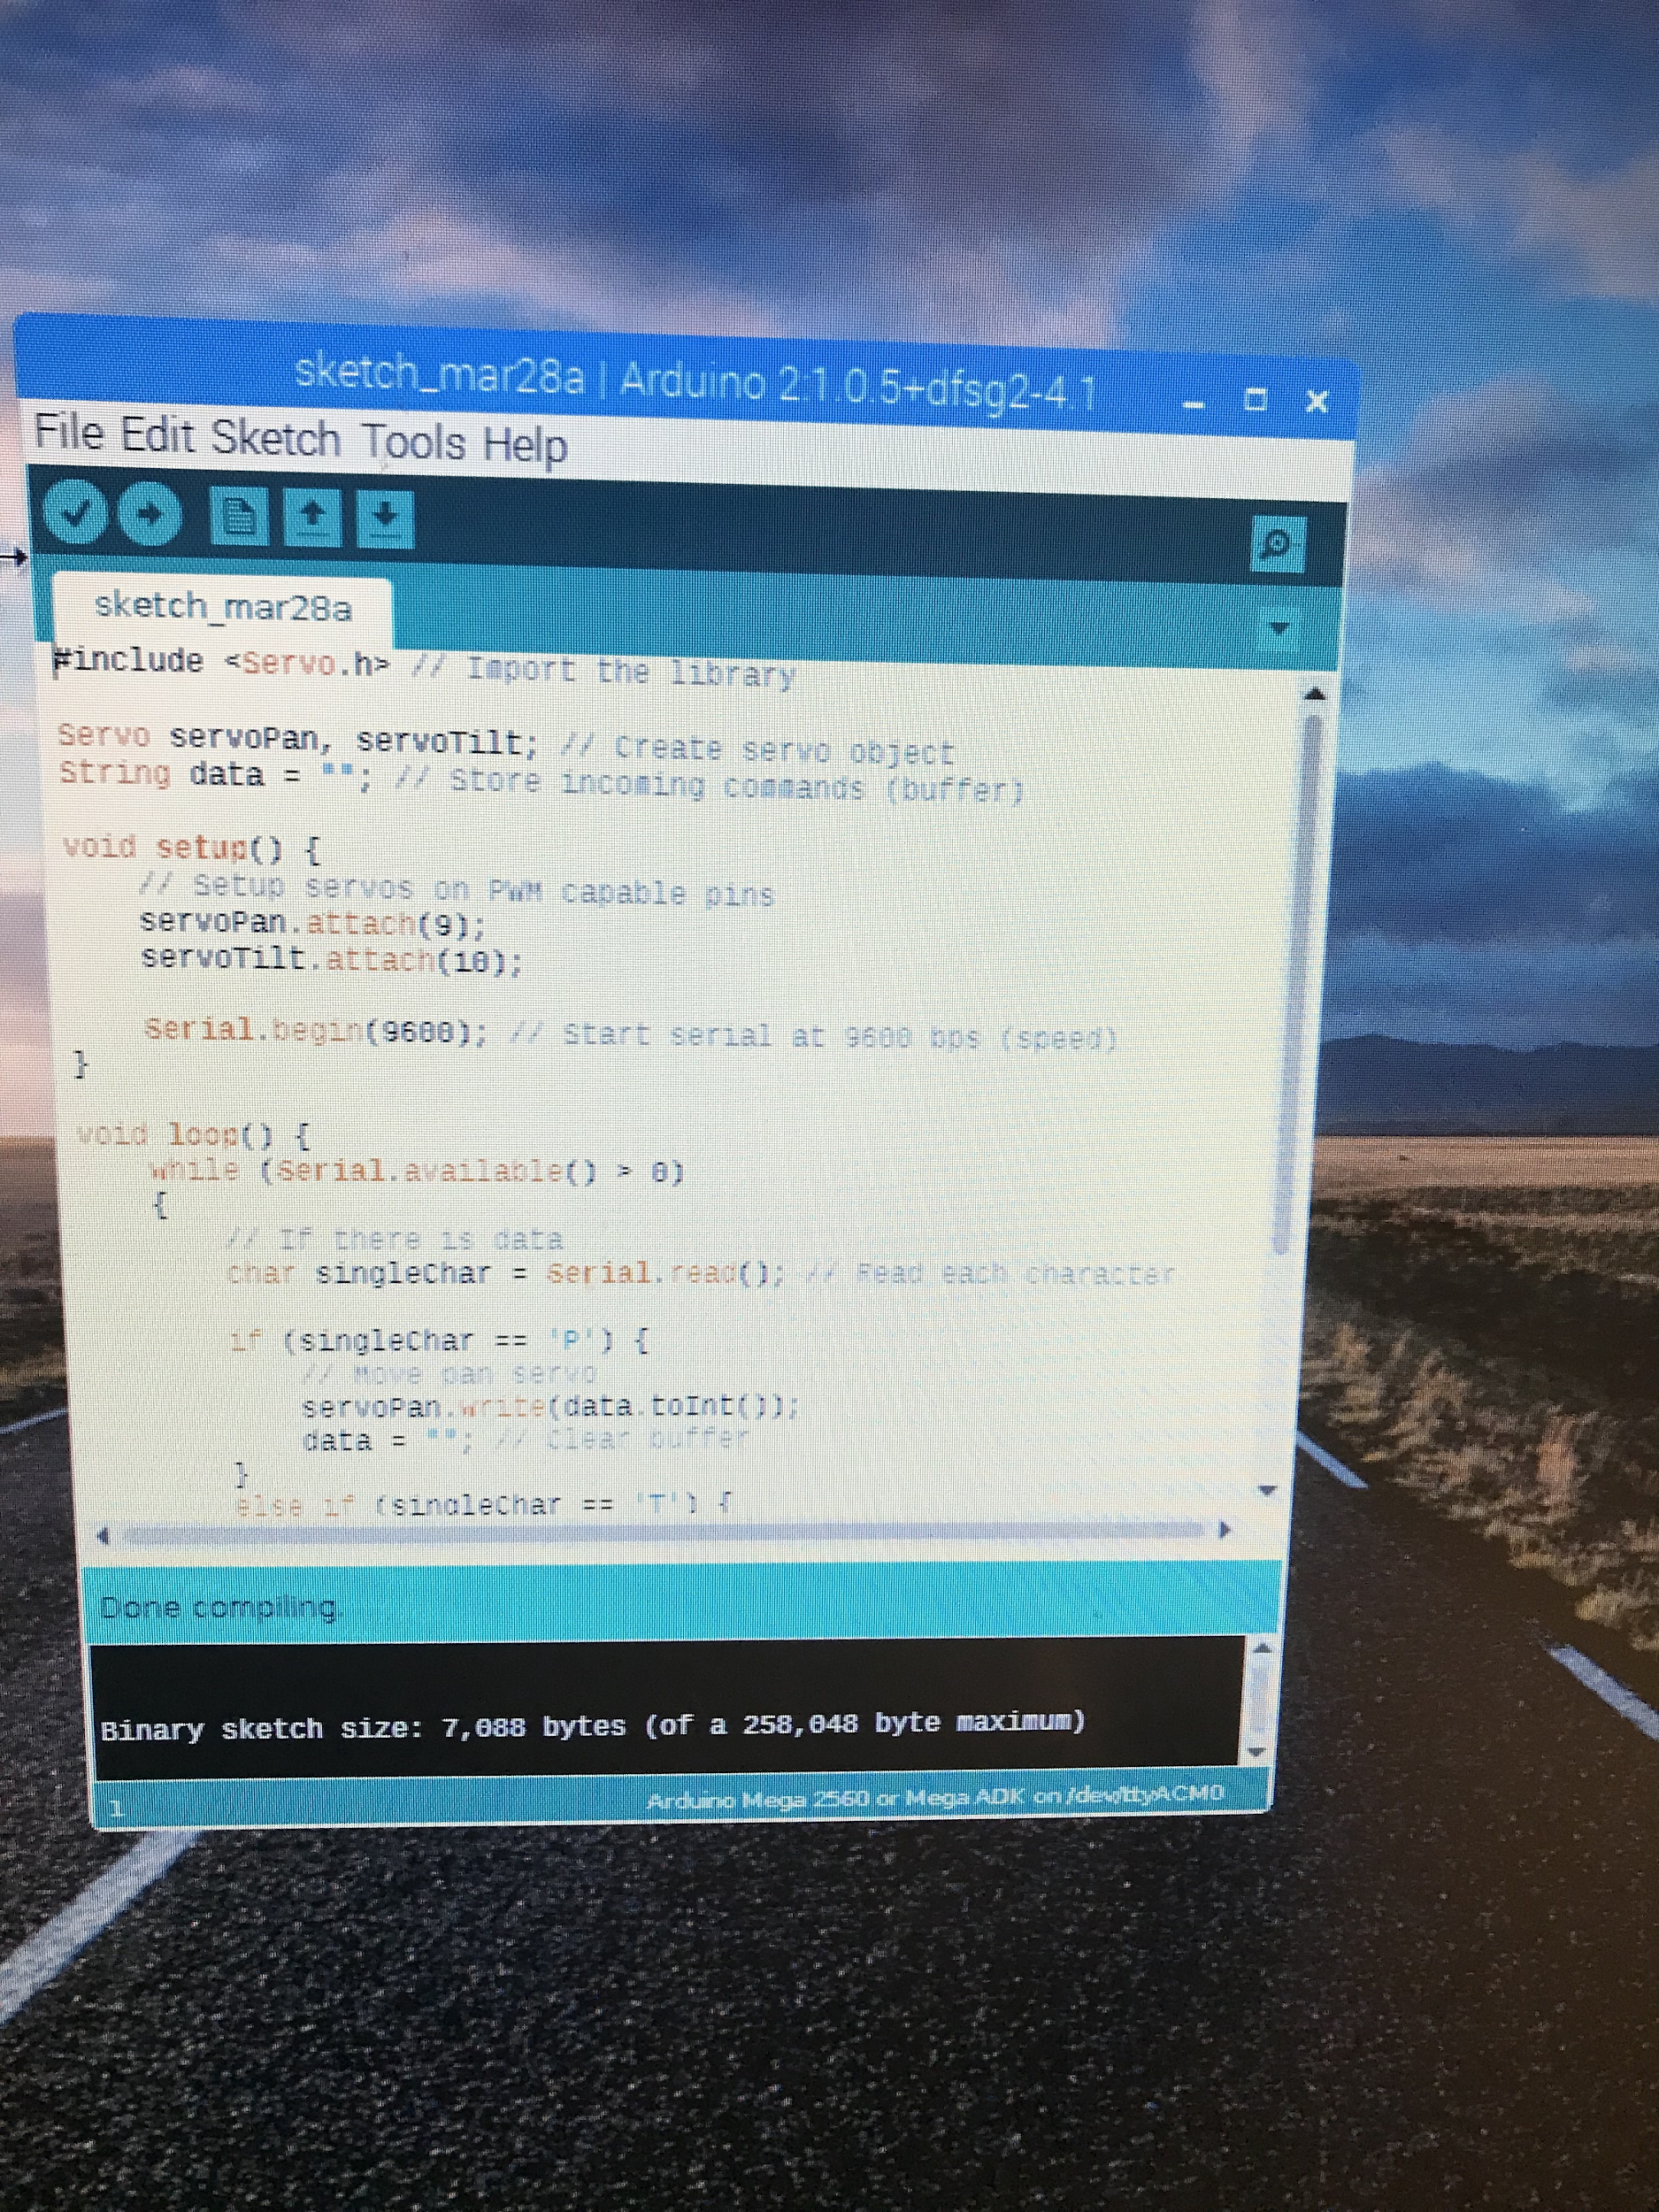

**Source code for Joystick and Servo communication on Arduino:**

**#include <Servo.h> // Import the library**

**Servo servoPan;**

**Servo servoTilt;**

**int joyX = 0;**

**int joyY = 1;**

**int servoVal;**

**//Servo servoPan//**

**//Servo servoTilt // Create servo object**

**String data = ""; // Store incoming commands (buffer)**

**void setup() {**

**// Setup servos on PWM capable pins**

**servoPan.attach(9);**

**servoTilt.attach(10);**

**Serial.begin(9600); // Start serial at 9600 bps (speed)**

**}**

**void loop()**

**{**

**servoVal = analogRead(joyX);**

**servoVal = analogRead(joyX);**

**servoVal = map(servoVal, 0, 1023, 0, 180);**

**servoPan.write(servoVal);**

**servoVal = analogRead(joyY);**

**servoVal = map(servoVal, 0, 1023, 70, 180);**

**servoTilt.write(servoVal);**

**delay(15);**

**while (Serial.available() > 0)**

**{**

**// If there is data**

**char singleChar = Serial.read(); // Read each character**

**if (singleChar == 'P') {**

**// Move pan servo**

**servoPan.write(data.toInt());**

**data = ""; // Clear buffer**

**}**

**else if (singleChar == 'T') {**

**// Move tilt servo**

**servoTilt.write(data.toInt());**

**data = ""; // Clear buffer**

**}**

**else {**

**data += singleChar; // Append new data**

**}**

**}**

**}**

## **D. Network Design**

**Linux motion package:**

Motion is a camera signal monitoring software. It helps to connect the webcam on the localhost using serial communication.

StreamControl _ port 8081 (HTTP) connects to the localhost.

Motion serves as a door opener to get the stream from the camera.

Sudo service motion start, stop.

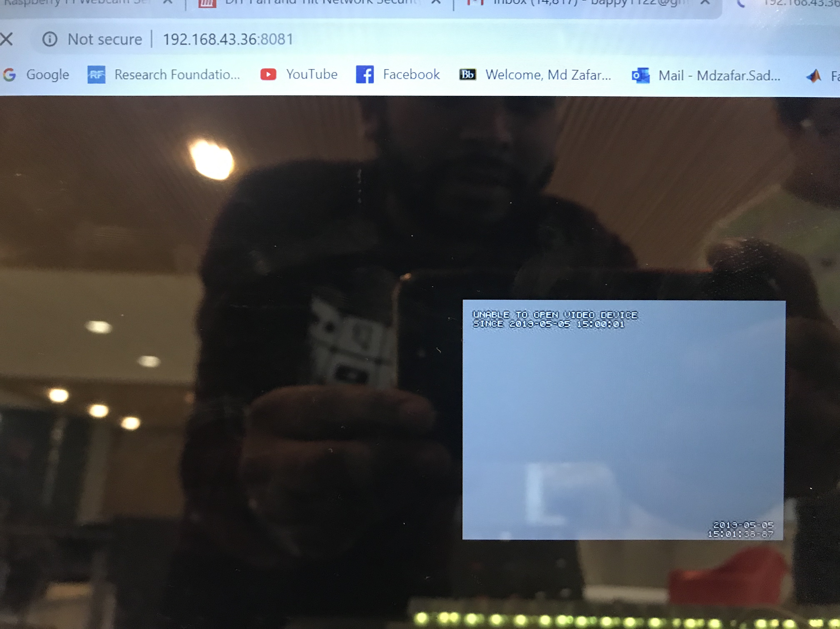

**Twisted Webserver Setup:**

Twisted is a webserver written in Python, which will listen for commands and then act accordingly. Once installed, create a Python script to execute commands (move the servos). This server will exchange messages between Arduino and the Raspberry Pi.

For example: From the Webpage it will send signal to the Arduino over the serial connection to control the servo’s left, right, up and down.

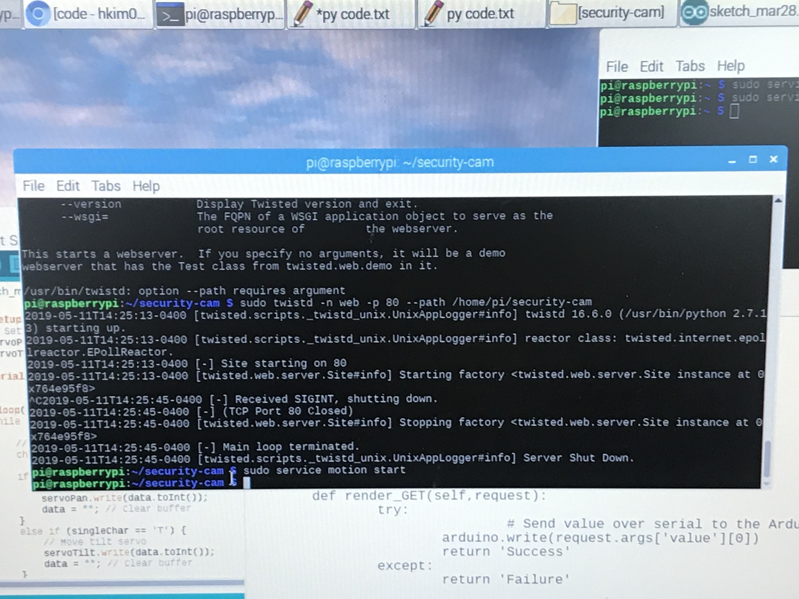

**Twisted python Code:**

# Import necessary files

import serial

from twisted.web.resource import Resource

# Setup Arduino at correct speed

try:

arduino = serial.Serial('/dev/ttyUSB0', 9600)

except:

arduino = serial.Serial('/dev/ttyUSB1', 9600)

class MoveServo(Resource):

isLeaf = True

def render_GET(self,request):

try:

# Send value over serial to the Arduino

arduino.write(request.args['value'][0])

return 'Success'

except:

return 'Failure'

resource = MoveServo()

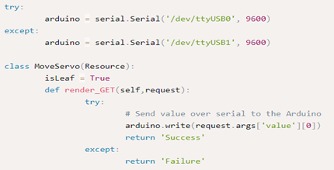

**Html webpage Setup:**

We have Created an index.html file that communicates to the webserver.

I had to run the webpage (index.html) few times on the compiler to make sure that it creates buttons and performs responsive functions to move servos.

It creates the following webpage that can easily control the servos which attached to the camera. I setup using onclick event so that per click the camera moves 10 degrees in any of the given direction.

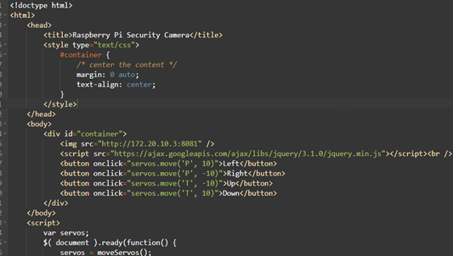

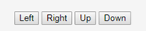

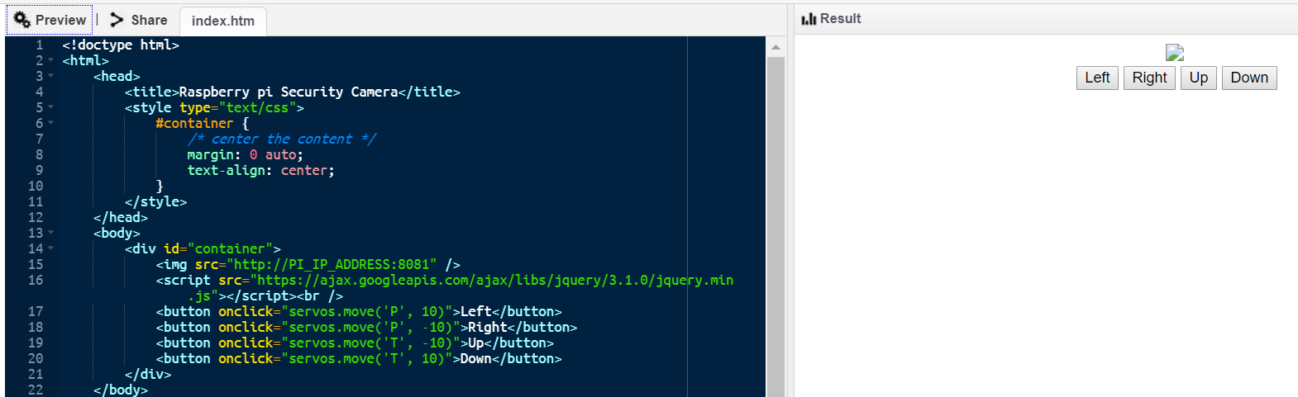

**HTML source code:**

<!doctype html>

<html>

<head>

<title>Raspberry pi Security Camera</title>

<style type="text/css">

#container {

/* center the content */

margin: 0 auto;

text-align: center;

}

</style>

</head>

<body>

<div id="container">

<img src="http://192.168.43.36:8081" />

<script src="https://ajax.googleapis.com/ajax/libs/jquery/3.1.0/jquery.min.js"></script><br />

<button onclick="servos.move('P', 10)">Left</button>

<button onclick="servos.move('P', -10)">Right</button>

<button onclick="servos.move('T', -10)">Up</button>

<button onclick="servos.move('T', 10)">Down</button>

</div>

</body>

<script>

var servos;

$( document ).ready(function() {

servos = moveServos();

});

function moveServos() {

// Store some settings, adjust to suit

var panPos = 70,

tiltPos = 90,

tiltMax = 170,

tiltMin = 45,

panMax = 170,

panMin = 20;

return {

move:function(servo, adjustment) {

var value;

if(servo == 'P') {

if(!((panPos >= panMax && adjustment > 0) || (panPos <= panMin && adjustment < 0))) {

// Still within allowed range, "schedule" the movement

panPos += adjustment;

}

value = panPos + 'P';

}

else if(servo == 'T') {

if(!((tiltPos >= tiltMax && adjustment > 0) || (tiltPos <= tiltMin && adjustment < 0))) {

// Still within allowed range, "schedule" the movement

tiltPos += adjustment;

}

value = tiltPos + 'T';

}

// Use AJAX to actually move the servos

$.get('http://192.168.43.36/servos.rpy?value=' + value);

},

}

}

</script>

</html>

# **D. Appendix**

## **Raspberry pi model B+**

The Raspberry Pi 3 Model B+ is the latest product in the Raspberry Pi 3 range, boasting a 64-bit quad core processor running at 1.4GHz, dual-band 2.4GHz and 5GHz wireless LAN, Bluetooth 4.2/BLE, faster Ethernet, and PoE capability via a separate PoE HAT

The dual-band wireless LAN comes with modular compliance certification, allowing the board to be designed into end products with significantly reduced wireless LAN compliance testing, improving both cost and time to market.

The Raspberry Pi 3 Model B+ maintains the same mechanical footprint as both the Raspberry Pi 2 Model B and the Raspberry Pi 3 Model B.

<https://static.raspberrypi.org/files/product-briefs/Raspberry-Pi-Model-Bplus-Product-Brief.pdf>

## **Arduino Uno**

The Arduino Uno is a microcontroller board based on the ATmega328 (datasheet). It has 14 digital input/output pins (of which 6 can be used as PWM outputs), 6 analog inputs, a 16 MHz ceramic resonator, a USB connection, a power jack, an ICSP header, and a reset button. It contains everything needed to support the microcontroller; simply connect it to a computer with a USB cable or power it with a AC-to-DC adapter or battery to get started. The Uno differs from all preceding boards in that it does not use the FTDI USB-to-serial driver chip. Instead, it features the Atmega16U2 (Atmega8U2 up to version R2) programmed as a USB-to-serial converter. Revision 2 of the Uno board has a resistor pulling the 8U2 HWB line to ground, making it easier to put into DFU mode. Revision 3 of the board has the following new features:

1.0 pinout: added SDA and SCL pins that are near to the AREF pin and two other new pins placed near to the RESET pin, the IOREF that allow the shields to adapt to the voltage provided from the board. In future, shields will be compatible both with the board that use the AVR, which operate with 5V and with the Arduino Due that operate with 3.3V. The second one is a not connected pin, that is reserved for future purposes. Stronger RESET circuit. Atmega 16U2 replace the 8U2.

"Uno" means one in Italian and is named to mark the upcoming release of Arduino 1.0. The Uno and version 1.0 will be the reference versions of Arduino, moving forward. The Uno is the latest in a series of USB Arduino boards, and the reference model for the Arduino platform. For detailed information <https://www.farnell.com/datasheets/1682209.pdf>

## **Sg90 Servo motor**

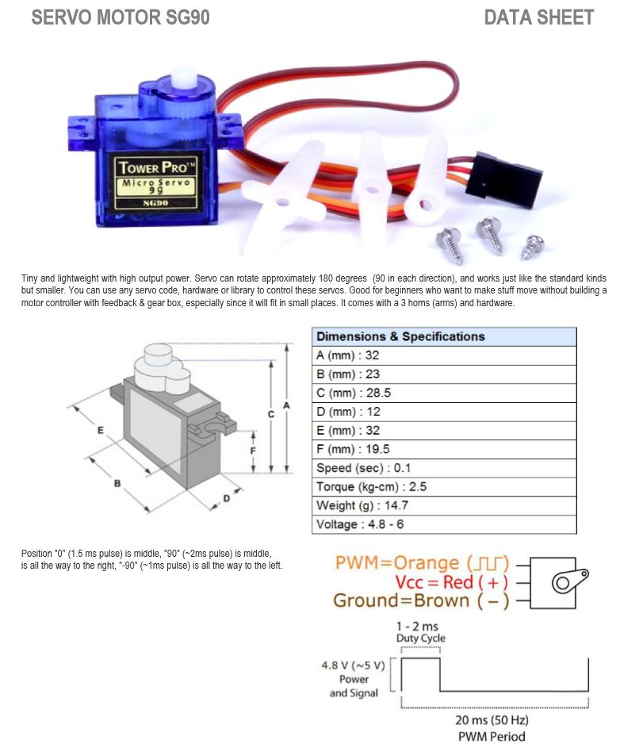

<http://www.ee.ic.ac.uk/pcheung/teaching/DE1_EE/stores/sg90_datasheet.pdf>

## **Pixycam**

<https://media.digikey.com/pdf/Data%20Sheets/Seeed%20Technology/101990056_Web.pdf>

# **Troubleshoot Details:**

* We had to face is networking issue while working under school network, it connects our pi and disconnects automatically after a few minutes, this happens because of school security purpose. We used hotspot to resolve this issue.
* Another issue is the web camera that we chose, after working couple of weeks we figured out this camera(pixy) can only detect objects based on shape, sizes and colors, doesn’t actually works in web stream environment. We used a different camera.
* Servo’s we promised that will handle Pan and tilt was not doing its job since it was not able to handle the camera weight, it was too heavy. So, we replaced the web camera with a small camera module.
* The picture quality is average because of the slow hotspot connectivity.

# **Use of Our Device:**

* Home security camera: Raspberry pi security camera can be use to monitor home,garage to protect important household items.
* Monitor baby and child: It can be used to monitor baby and child and their activity using the local webpage.
* Office security camera: It’s extremely useful to use it in the office environment to monitor office activity.
* Traffic monitor device: Monitoring traffic flow on the road is extremely important to keep road safe, traffic enforcement can use this device to get wider angle of the traffic flow.
* Back up camera: It can be useful as a backup camera to monitor certain activity.

# **Future Plan:**

* We will develop an application so that user can able to monitor his office, house, garage etc.
* We will rebuild entire structure using 3D printer.
* Enhance security to raspberry pi such as encryption.
* Can upload the video to cloud service.
* Can implement NAS to store the web stream on our own server.

# **Conclusion:**

The Raspberry pi web security camera system has been aimed to design in such a way that it can fulfil the needs of the user for monitor a wider area. For instance, it can be used by any person working in industry to be aware of the activity being happened at their own working places in their absence. while at another instance it can be used for spy purposes at bank lockers, storage houses. Finally, for future plan we will implement a Smartphone application which will be easy to control the angle of the camera.